Module 2
Git Assignment -1
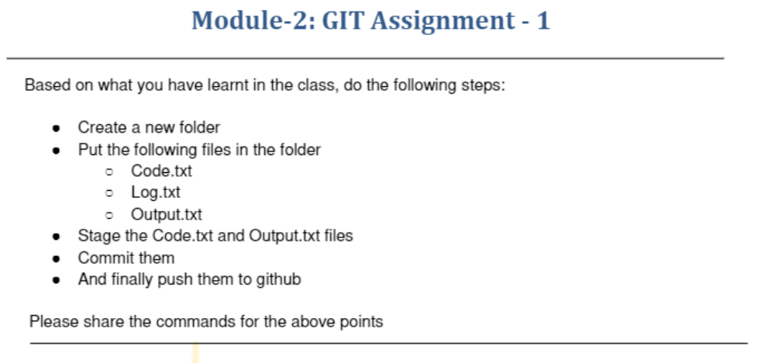
ubuntu@ip-172-31-25-3:~$ mkdir new
ubuntu@ip-172-31-25-3:~$ cd new
ubuntu@ip-172-31-25-3:~/new$ vi code.txt
ubuntu@ip-172-31-25-3:~/new$ vi log.txt
ubuntu@ip-172-31-25-3:~/new$ vi output.txt
ubuntu@ip-172-31-25-3:~/new$ git init
Initialized empty Git repository in /home/ubuntu/new/.git/
ubuntu@ip-172-31-25-3:~/new$ git add code.txt
ubuntu@ip-172-31-25-3:~/new$ git commit code.txt
[master (root-commit) 6e4a679] Initial commit code.txt
1 file changed, 1 insertion(+)
create mode 100644 code.txt
ubuntu@ip-172-31-25-3:~/new$ git commit -m "Initial commit output.txt"
[master de7cacc] Initial commit output.txt
1 file changed, 1 insertion(+)
create mode 100644 output.txt
ubuntu@ip-172-31-25-3:~/new$ git remote add origin git@github.com:vcgatate/Git_assignment-1.git
ubuntu@ip-172-31-25-3:~/new$ git push origin master
Warning: Permanently added the RSA host key for IP address '140.82.113.4' to the list of known hosts.
Enumerating objects: 6, done.
Counting objects: 100% (6/6), done.
Compressing objects: 100% (3/3), done.
Writing objects: 100% (6/6), 502 bytes | 502.00 KiB/s, done.
Total 6 (delta 0), reused 0 (delta 0)
remote:
remote: Create a pull request for 'master' on GitHub by visiting:
remote: https://github.com/vcgatate/Git_assignment-1/pull/new/master
remote:
To github.com:vcgatate/Git_assignment-1.git
* [new branch] master -> master
